|  |  |
| --- | --- |
| A picture of a winding road and trees  Project Plan Document  4 JUNE 2023 |  |

*• Number of the team: 2*

*• Name of the team: Quality Life*

*• Name and student number of team leader:*

*ZWELAKHE NKOSI - ST10101933*

*• Name and student numbers of team:*

*NOKWETHEMBA CELE –ST10101860*

*• Name and Logo of the app:*

LAUNDRY APP



Table of Contents

1. Introduction Project Plan: Digitizing Laundry Services 3

Identification organisation and project: 3

Introduction: 3

Problem Domain: 3

Business Processes: 3

System Requirements: 4

Functions of the App System: 4

Stakeholders and Their Functions: 5

Inputs, Outputs, and Processing Components: 5

2. Project Plan Criteria: Laundries App 6

Project Scope and Key Role Players: 7

Milestones and Deliverables: 7

Work Breakdown Structure (WBS): 8

Project Schedule/Plan: Laundry App 9

3. Requirements Analysis Criteria 10

Functional Requirements for the Laundry App: 11

Use Case Diagram: 11

Logical System Model for the Laundry App: 12

Business Solution Requirement and Analysis for the Laundry App: 13

4. System Design 15

Application Architecture of the Laundry App: 15

Designing the GUI (Graphical User Interface): 16

Database Design with Full Referential Integrity: 22

Reports: 22

# Introduction Project Plan: Digitizing Laundry Services

## Identification organisation and project:

APPLY PRESSURE SHOE CLEANERS

## Introduction:

The purpose of this project plan is to outline the implementation of a digital app for companies that provide laundry services. The app will allow customers to book and pay for their laundry services online, providing a convenient collection and delivery system. This plan will cover various aspects, including the problem domain, business processes, system requirements, functions of the app system, stakeholders, and their functions, as well as inputs, outputs, and processing components.

## Problem Domain:

The traditional laundry service industry often relies on in-person or phone-based bookings, which can be time-consuming and inconvenient for customers. By digitizing the process, we aim to provide an all-in-one experience for customers to book and pay for laundry services online, as well as offer a collection and delivery service through a single app. This will enhance customer convenience, modernise operations, and increase the overall efficiency of the laundry service companies.

## Business Processes:

A. **Customer Registration and Profile Creation:**

-Users will be able to create their profiles by providing their personal information and contact details.

-The app will store this information securely for future use.

B. **Service Selection and Booking:**

-Users will be able to browse and select laundry services available in their area.

-They can choose from various service options, such as regular laundry, dry cleaning, or specialty cleaning.

-Once a service is selected, users can specify collection and delivery preferences, including time slots.

C**. Payment and Invoicing:**

-The app will provide secure online payment options, allowing users to pay for their selected services.

-Users will receive invoices and payment confirmations within the app.

D. **Collection and Delivery:**

-Once a booking is confirmed and payment is received, the app will coordinate the collection and delivery process.

-Users can track the status of their laundry, receive notifications about pickup and delivery.

## System Requirements:

A. **Frontend:**

-Natural user interface for easy navigation and all-in-one booking experience.

-Support for multiple platforms, including web and mobile applications.

-Secure user authentication and profile management.

B. **Backend:**

-Strong database management to store user profiles, services, bookings, and transactions securely.

-Integration with secure payment gateways for online transactions.

-Integration with a geolocation system to identify service availability in the user's area.

-Order management system to track the status of bookings, collection, and delivery.

C. **Infrastructure:**

-Sufficient server capacity to handle coexisting user requests.

-Regular data backups to ensure data integrity and availability.

-Security measures to protect user data and prevent unauthorized access.

## Functions of the App System:

A. **User Registration and Profile Management:**

-Allow users to create accounts, log in, and manage their profiles.

B. **Service Selection and Booking:**

-Display available laundry services based on the user's location.

-Enable users to select desired services, specify preferences, and book appointments.

C. **Secure Payment Processing:**

-Integrate with trusted payment gateways to process online transactions securely.

D. **Collection and Delivery Coordination:**

-Provide real-time updates on the status of laundry collection and delivery.

-Allow users to track the progress and receive notifications about their laundry status.

E. **Order Management:**

-Manage and track bookings, including order history, delivery status, and invoices.

## Stakeholders and Their Functions:

A. **Customers:**

-Create profiles, book services, and make payments online.

-Provide feedback and reviews for service quality improvement.

B. **Laundry Service Providers:**

-Manage service availability, pricing, and order fulfilment.

-Receive notifications and updates about customer bookings.

C. **App Administrators:**

-Manage user accounts and profiles.

-Oversee system performance, security, and updates.

-Analyse data for business insights and improvements.

## Inputs, Outputs, and Processing Components:

A. **Inputs:**

-User registration and profile data.

-Service availability and pricing information.

-Payment details and transaction data.

B. **Outputs:**

-Booking confirmations and receipts.

-Notifications about collection and delivery updates.

-Invoices and payment confirmations.

C. **Processing Components:**

-User authentication and profile management.

-Payment processing and transaction management.

-Order tracking and status updates.

By following this project plan, we aim to transform traditional laundry services into a digital platform that offers convenience and efficiency for customers and service providers alike. The outlined processes, system requirements, and functions will contribute to a successful implementation of the laundry service app, benefiting all stakeholders involved.

# 2. Project Plan Criteria: LAUNDRY APP

**Introduction:**

The purpose of this project plan is to outline the development and implementation of a laundry app system that enables customers to book and pay for laundry services online, while providing a convenient collection and delivery process. The plan will cover key aspects such as project scope, milestones and deliverables, work breakdown structure (WBS), risk analysis, and technical and economic feasibility.

Here is an approximate cost breakdown for developing a laundry app in ZAR:

1. Development Costs:
   * Backend Development: R100 000 - R200 000
   * Frontend Development: R80 000 - R150 000
   * Mobile App Development (iOS and Android): R150 000 - R300 000
   * Integration and Testing: R50 000 - R100 000
2. Design and User Experience:
   * UI Design: R50 000 - R100 000
   * Prototyping: R30 000 - R70 000
3. Backend Infrastructure:
   * Hosting and Server Costs: R10 000 - R50 000
   * Security Measures: R20 000 - R60 000
4. Quality Assurance and Testing:
   * QA Testing: R30 000 - R80 000
   * Bug Fixes and Iterations: R20 000 - R50 000
5. Launch and Deployment:
   * App Store Fees: R2 000 - R5 000 (per platform)
   * Marketing and Promotion: R50 000 - R100 000
6. Ongoing Maintenance and Updates:
   * Ongoing Support: R20 000 - R60 000 (per year)
   * Feature Enhancements: Costs can vary based on the specific requirements.

## Project Scope and Key Role Players:

A. **Scope:**

-Develop a user-friendly app system for customers to book and pay for laundry services online.

-Provide an all-in-one collection and delivery process integrated within the app.

-Support user registration, profile creation, and management.

-Implement secure payment processing and invoicing functionality.

B. **Key Role Players:**

-Customers: Users of the app who book and pay for laundry services.

-Laundry Service Providers: Businesses that offer laundry services through the app.

-App Administrators: Manage user accounts, system performance, and updates.

## Milestones and Deliverables:

A. **Milestones:**

**Project Initiation:**

-Finalize project plan, scope, and key requirements.

-Identify and assign project team members and stakeholders.

**Design and Development:**

-Complete user interface design

-Develop user registration and profile management module.

-Implement service selection and booking functionality.

**Payment Processing and Invoicing:**

-Integrate secure payment gateway for online transactions.

- Implement invoicing and payment confirmation features.

**Collection and Delivery Coordination:**

-Develop a system to track laundry collection and delivery.

-Implement real-time updates and notifications for users.

**Testing and Quality Assurance:**

-Conduct thorough testing to ensure app functionality and performance.

-Address any issues or bugs identified during testing phase.

**Deployment and Launch:**

-Launch the app on web and mobile platforms.

-Provide support and training to key stakeholders.

B. **Deliverables:**

-Project plan, requirements specification, and design documents.

-User registration and profile management module.

-Functional service selection and booking system.

-Secure payment processing and invoicing functionality.

-Collection and delivery coordination system with real-time updates.

-Fully developed and tested app available on web and mobile platforms.

## Work Breakdown Structure (WBS):

**System Analysis and Requirements Gathering:**

-Identify functional and non-functional requirements.

-Conduct market research and competitor analysis.

**Design and Development:**

-User interface design.

-User registration and profile management module.

-Service selection and booking functionality.

-Integration with payment gateway.

-Invoicing and payment confirmation features.

-Collection and delivery coordination system.

**Testing and Quality Assurance:**

-Develop test plans and test cases.

-Conduct functional, integration, and performance testing.

**Deployment and Launch:**

-Prepare deployment strategy for web and mobile platforms.

-Provide user training and support.

**Risk Analysis:**

-Identify potential risks and challenges throughout the project lifecycle.

-Assess the impact and probability of each risk.

-Develop risk mitigation strategies and contingency plans.

-Regularly monitor and review risks to ensure timely resolution.

**Technical and Economic Feasibility:**

-Evaluate the technical requirements for app development and deployment.

-Assess the availability of necessary resources, technologies, and infrastructure.

-Conduct an economic analysis to determine the financial feasibility of the project.

-Consider factors such as development costs, potential revenue, and return on investment.

By following this project plan, the aim is to successfully develop and implement a laundry app system that modernises

## Project Schedule/Plan: Laundry App

Project Initiation Phase:

-Duration: 2 weeks

-Define project scope and objectives.

-Identify key stakeholders and assign project team members.

-Develop the project plan and obtain necessary approvals.

**Requirements Gathering and Analysis:**

-Duration: 3 weeks

-Conduct market research and competitor analysis.

-Gather functional and non-functional requirements.

-Define user stories and use cases.

Design and Development Phase:

**User Interface Design:**

-Duration: 2 weeks

-Create wireframes and mockups for the app.

-Seek feedback from stakeholders and make necessary revisions.

**User Registration and Profile Management:**

-Duration: 4 weeks

-Develop the module for user registration and profile creation.

-Implement secure authentication and profile management features.

**Service Selection and Booking Functionality:**

-Duration: 6 weeks

-Design and implement the module for browsing and selecting laundry services.

-Develop the booking functionality with date, time, and service preferences.

**Payment Processing and Invoicing:**

-Duration: 4 weeks

-Integrate a secure payment gateway for online transactions.

-Develop the invoicing and payment confirmation features.

**Collection and Delivery Coordination:**

-Duration: 5 weeks

-Implement a system to track laundry collection and delivery.

-Integrate real-time updates and notifications for users.

**Testing and Quality Assurance:**

-Duration: 3 weeks

-Develop test plans and test cases for all app functionalities.

-Conduct functional, integration, and performance testing.

-Address any issues or bugs identified during the testing phase.

**Deployment and Launch:**

-Duration: 2 weeks

-Prepare the deployment strategy for web and mobile platforms.

-Conduct user training and provide support during the launch phase.

**Project Closure and Maintenance:**

-Duration: Ongoing

-Conduct a project review and gather feedback from stakeholders.

-Handover project documentation and codebase.

-Provide ongoing maintenance and support as required.

# 3. Requirements Analysis Criteria

## Functional Requirements for the Laundry App:

**User Registration and Profile Management:**

-Users can create accounts and register with their personal information.

-Users can update and manage their profiles, including contact details and preferences.

**Service Selection and Booking:**

-Users can browse and view available laundry services.

-Users can select desired services and specify preferences such as cleaning type, garment specifications, and special instructions.

-Users can view pricing information and select convenient time slots for pickup and delivery.

**Secure Payment Processing:**

-Users can securely make online payments for selected services.

-The app should integrate with trusted payment gateways to facilitate secure transactions.

**Collection and Delivery Coordination:**

-Users can track the status of their laundry orders, including pickup and delivery.

-Users receive real-time notifications about order status updates, such as order confirmation, pickup, and delivery.

**Order Management:**

-Laundry service providers can manage and track incoming orders.

-Providers can update the status of each order, including order acceptance, order completion, and delivery.

**User Reviews and Feedback:**

-Users can provide reviews and ratings for laundry service providers.

-Users can provide feedback on the quality of service received.

## Use Case Diagram:

+-----------------+

| User |

+-----------------+

|

|

+-----------------------------+

| Register |

| Log In |

| Update Profile |

| Browse Services |

| Select Service |

| Book Service |

| Make Payment |

| Track Order |

| Provide Feedback |

+-----------------------------+

|

|

+-----------------+

| Laundry |

| Service |

| Provider |

+-----------------+

## Logical System Model for the Laundry App:

**Inputs:**

-User Registration Information: Name, contact details, address.

-Service Selection Details: Service preferences, special instructions.

-Payment Information: Payment details, billing address.

**Outputs:**

-User Profile: Registered user details and preferences.

-Service Booking Confirmation: Confirmation of selected services, date, and time.

-Payment Confirmation: Confirmation of successful payment transaction.

-Order Status Updates: Notifications about order status (e.g., order confirmation, pickup, delivery).

-User Feedback: Reviews and ratings provided by users.

Processes:

**User Registration and Profile Management:**

-Input: User registration information.

-Output: User profile with registered.

**Service Selection and Booking:**

-Input: Service selection details.

-Output: Service booking confirmation, order details.

**Secure Payment Processing:**

-Input: Payment information.

-Output: Payment confirmation.

**Collection and Delivery Coordination:**

-Input: Order details, pickup and delivery information.

-Output: Order status updates, notifications to users.

**Order Management:**

-Input: Order status updates, completion status.

-Output: Updated order status, delivery completion updates.

**User Reviews and Feedback:**

-Input: User feedback and ratings.

-Output: User feedback and ratings recorded for service providers.

**Relationships:**

-User Registration and Profile Management is related to Service Selection and Booking as registered user details and preferences are used to personalize service selections.

-Service Selection and Booking is related to Secure Payment Processing as users need to make payments for their selected services.

-Collection and Delivery Coordination is related to Order Management as it involves tracking and updating the status of orders.

-User Reviews and Feedback is related to Service Providers as users can provide feedback and ratings for the services they received.

## Business Solution Requirement and Analysis for the Laundry App:

1. **Business Objectives:**
   * Provide a convenient and user-friendly platform for customers to book and pay for laundry services online.
   * Modernise the collection and delivery process to enhance customer satisfaction and operational efficiency.
   * Enable laundry service providers to expand their customer reach and improve business visibility.
   * Facilitate secure and seamless payment transactions for both customers and service providers.
2. **User Requirements:**
   * Customers:
     + User-friendly interface for easy registration, profile creation, and service selection.
     + Convenient scheduling options for pickup and delivery.
     + Real-time order tracking and status updates.
     + Secure payment processing and transparent pricing information.
     + Ability to provide feedback and ratings for service providers.
   * Laundry Service Providers:
     + Easy on boarding process to join the platform as a service provider.
     + Access to a dashboard for managing incoming orders, order status, and customer details.
     + Integration with the collection and delivery system for efficient logistics management.
     + Ability to view and respond to customer reviews and ratings.
     + Seamless integration with the payment gateway for secure and timely transactions.
3. **Technical Requirements:**
   * Cross-platform compatibility: The app should be available on both web and mobile platforms.
   * Scalability and performance: The system should handle a large volume of simultaneous user interactions.
   * Security: Implement strong security measures to protect user data and ensure secure payment processing.
   * Integration capabilities: Integrate with external systems, such as payment gateways and logistics providers.
   * User interface and experience: Design an intuitive and user-friendly interface for seamless interactions.
4. **Business Analysis:**
   * Market Analysis: Assess the competitive landscape and customer demand for online laundry services.
   * Stakeholder Analysis: Identify key stakeholders and understand their roles, responsibilities, and needs.
   * Cost-Benefit Analysis: Evaluate the economic feasibility of the app, considering development costs, revenue potential, and return on investment.
   * Risk Analysis: Identify potential risks and challenges that may impact the success of the app implementation and develop mitigation strategies.
5. **Implementation Plan:**
   * Define a project plan with clear milestones, deliverables, and a timeline.
   * Allocate resources, both human and technical, to support the development and implementation phases.
   * Conduct user acceptance testing to ensure the app meets the defined requirements and user expectations.
   * Provide training and support to key stakeholders, including customers and service providers.
   * Monitor and evaluate the app's performance post-launch, making necessary improvements and enhancements based on user feedback and market trends.

By addressing the business objectives, understanding user requirements, considering technical aspects, and conducting thorough analysis, the laundry app solution can be effectively designed and implemented to meet the needs of both customers and service providers in the laundry services industry.

# 4. System Design

## Application Architecture of the Laundry App:

There are different possible models for the application architecture of the system. Let's explore four options: three-tier design, two-tier design, thin or thick clients, and centralized design with dumb terminals.

1. **Three-Tier Design:** In a three-tier design, the application architecture consists of three layers: presentation layer, business logic layer, and data storage layer.

* Presentation Layer: This layer handles the user interface and user interactions. It can be implemented as a web or mobile application.
* Business Logic Layer: This layer contains the application's logic and processes user requests. It communicates with the presentation layer and interacts with the data storage layer.
* Data Storage Layer: This layer manages the storage and retrieval of data. It can include databases or other storage systems to store user profiles, service information, and order details.

1. **Two-Tier Design:** In a two-tier design, the application architecture consists of two layers: client layer and server layer.

* Client Layer: This layer includes the user interface and application logic, which runs on the user's device (web browser or mobile app). It handles user interactions and communicates directly with the server layer.
* Server Layer: This layer includes the server-side application and database. It processes client requests, manages the business logic, and handles data storage and retrieval.

1. **Thin or Thick Clients:** In a thin client model, the client-side application has minimal functionality and relies heavily on the server-side application for processing and data management. The thin client communicates with the server for most operations. In a thick client model, the client-side application has more processing capabilities and can handle some business logic and data management tasks locally. It still communicates with the server for specific operations.
2. **Centralized Design with Dumb Terminals:** In a centralized design with dumb terminals, the client devices (terminals) have limited processing power and rely entirely on the central server for processing and data management. The server performs all the business logic and data storage tasks, and the dumb terminals simply display the user interface and send user input to the server for processing.

Each architectural model has its advantages and considerations based on factors such as scalability, performance, security, and deployment requirements. The choice of architecture would be made based on the specific needs and constraints of the laundry app system, considering factors such as expected user base, budget, infrastructure, and technical capabilities.

## Designing the GUI (Graphical User Interface):

1. Home Screen:
   * Include a clean and attractive home screen with a logo and app name.
   * Display key features, such as service selection, booking, order tracking, and user profile.

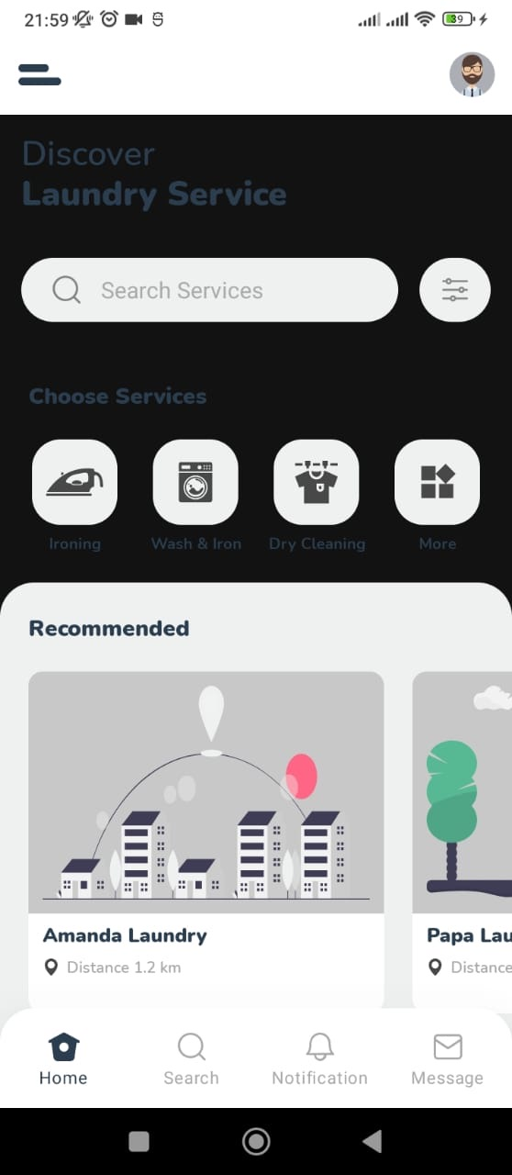

1. User Registration and Login:
   * Design a registration form for new users to create an account.
   * Provide a login screen for existing users to access their accounts securely.

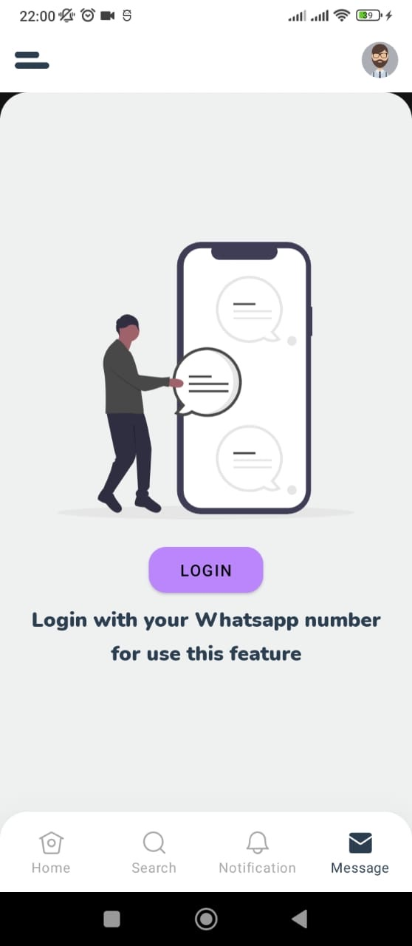

1. Service Selection and Booking:
   * Present laundry service options in a visually appealing and organized manner.
   * Include filters and search functionality to help users find specific services.
   * Provide a clear and straightforward booking process, allowing users to select service types, specify garment details, and choose convenient pickup and delivery slots.



1. User Profile Management:
   * Create a user profile section where users can view and update their personal information, contact details, and preferences.
   * Include options for managing saved addresses and payment methods.

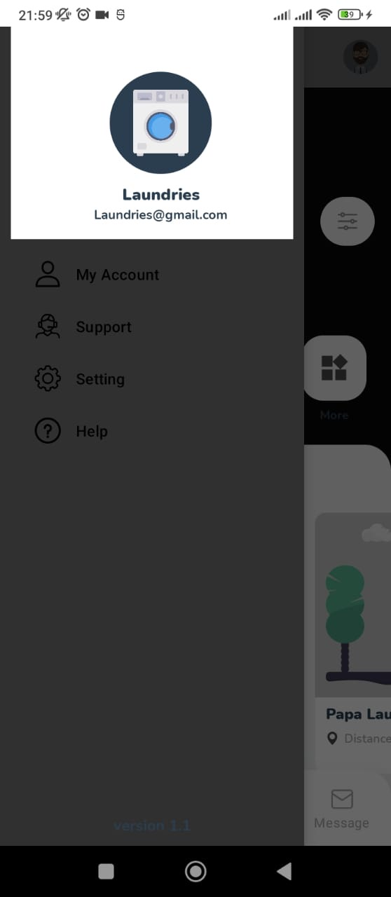

1. Order Tracking and Notifications:
   * Design a section where users can track the status of their orders, including real-time updates on pickup and delivery.
   * Implement push notifications or in-app notifications to inform users about order confirmations, status changes, and delivery completion.

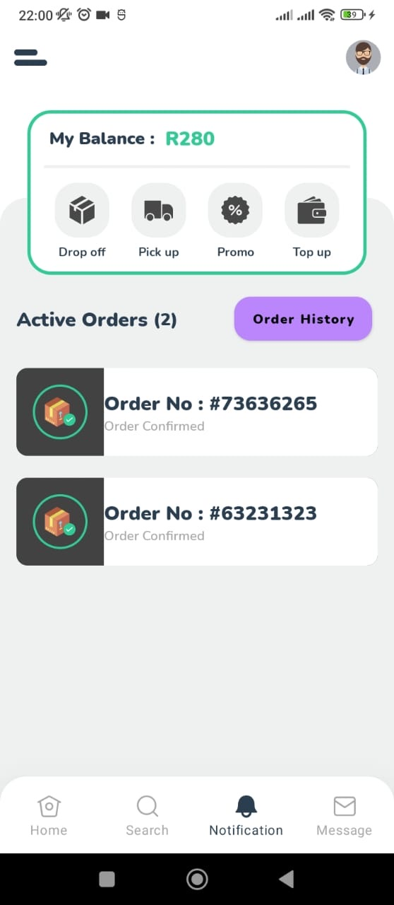

1. Payment Processing:
   * Integrate a secure and user-friendly payment gateway to facilitate seamless and secure transactions.
   * Clearly display pricing information and provide a summary of the selected services and charges before proceeding to payment.
2. Feedback and Reviews:
   * Allow users to provide feedback and ratings for the services they receive.
   * Design a section where users can view and read reviews from other customers to help them make informed decisions.

## Database Design with Full Referential Integrity:

The database for the laundry app should be designed to store and manage the relevant data efficiently while ensuring data integrity.

1. User Table:
   * Fields: User ID, Name, Contact Details, Username, Password, etc.
2. Service Table:
   * Fields: Service ID, Service Name, Description, Price, etc.
3. Order Table:
   * Fields: Order ID, User ID (foreign key), Service ID (foreign key), Order Status, Order Date, Pickup Date, Delivery Date, etc.
4. Address Table:
   * Fields: Address ID, User ID (foreign key), Address Line 1, Address Line 2, City, State, Postal Code, etc.
5. Payment Table:
   * Fields: Payment ID, User ID (foreign key), Order ID (foreign key), Payment Date, Amount, Payment Method, etc.

Appropriate foreign key constraints are established to maintain referential integrity between the tables.

## Reports:

The laundry app can generate various reports to provide valuable insights and aid in business operations. Some possible reports include:

1. Order Summary Report:
   * Provides a summary of orders received within a specific period, including order details, customer information, and payment status.
2. Revenue Report:
   * Shows the total revenue generated from laundry services over a defined time frame.
3. Customer Feedback Report:
   * Compiles customer reviews and ratings for service providers, allowing analysis of customer satisfaction levels.
4. Service Performance Report:
   * Analyses the popularity and performance of different laundry services based on the number of bookings and customer feedback.
5. User Activity Report:
   * Tracks user activity, such as new registrations, login patterns, and frequency of bookings.

SPEECH

Ladies and gentlemen,

Today, I am here to present a comprehensive solution for the digital transformation of laundry services through the development of a laundry app. This app aims to revolutionize the way customers’ book and pay for laundry services, providing them with a seamless and convenient online platform. The business we have targeted is Apply pressure shoe cleaners

The laundry app's scope encompasses several key components. Users can create profiles, enabling them to view and book laundry services available in their area. They can select services based on their preferences, specify garment details, and even provide special instructions.

To ensure efficient logistics management, the app incorporates a collection and delivery feature. Users can track the status of their orders in real-time, receiving notifications at every stage, from order confirmation to pickup and delivery. This feature ensures transparency and enhances customer satisfaction.

The laundry app also prioritizes user feedback. Customers can rate and provide reviews for the laundry service providers, enabling continuous improvement and helping other users make informed decisions. The app raises a sense of trust and accountability within the community.

In terms of the system's architecture, we have considered various models such as three-tier design, two-tier design, thin or thick clients, and centralized design with dumb terminals. Each model has its advantages, and the choice depends on factors like scalability, performance, and security.

Furthermore, we have designed an intuitive and visually appealing Graphical User Interface (GUI) that allows users to navigate seamlessly through the app. It offers user-friendly features such as registration, service selection, order tracking, COD (cash on delivery) and profile management. The GUI aims to provide an excellent user experience while ensuring ease of use and accessibility.

Underlying the app is a forceful and efficient database design with full referential integrity. This ensures data consistency and reliability, enabling smooth operations and seamless interactions between users, services, orders, addresses, and payments.

To drive business insights and aid in decision-making, the app generates informative reports. These reports include order payment summaries, customer feedback and user activity. The reports are designed to provide valuable insights and facilitate business growth and improvement.

In conclusion, the laundry app solution we have presented today brings together a comprehensive set of functionalities, a well-designed user interface, a strong database architecture, and insightful reporting capabilities. It addresses the needs of both customers and service providers, restructuring the laundry service experience and development of a digital transformation in the industry.

Thank you for your attention, and we look forward to how this laundry app can revolutionize the business and enhance customer satisfaction.